KEY International Steps for Donating Online

- Go to http://www.keyinternational.org/donate.html
- Scroll to the bottom of the screen and click on the donate button.
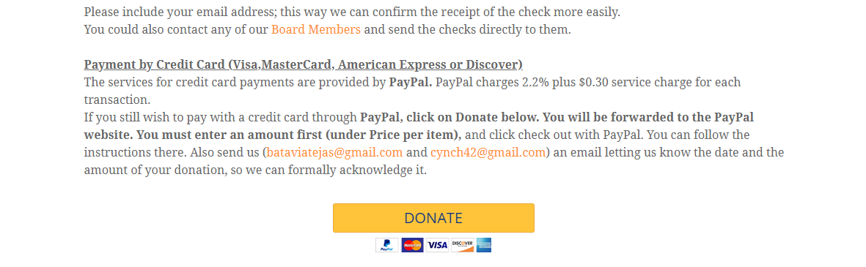
- Enter Donation amount in the price per item.
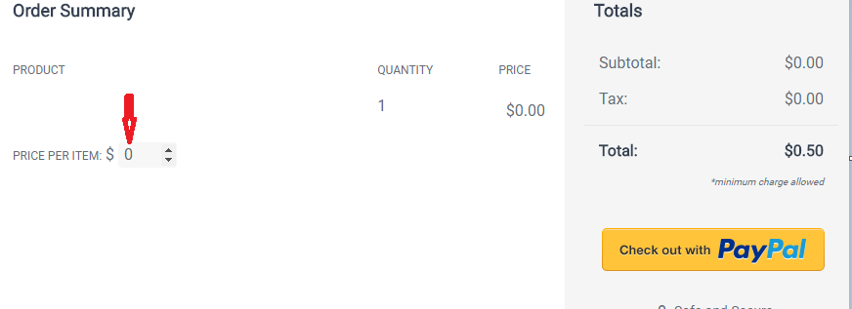
- Click on the Checkout with PayPal button which will take you to the below page
